12) Configuration of Dynamic Static Routing Protocol using Packet tracer.

Introduction:-

Routing protocols are used to facilitate the exchange of routing information between routers. Routing protocols allow routers to dynamically learn information about remote networks and automatically add this information to their own routing tables, Routing protocols determine the best path to each network, which is then added to the routing table. One of the primary benefits of using a dynamic routing protocol is that routers exchange routing information whenever there is a topology change. This exchange allows routers to automatically learn about new networks and also to find alternate paths if there is a link failure to a current network. Compared to static routing, dynamic routing protocols require less administrative overhead. However, the expense of using dynamic routing protocols is dedicating part of a router’s resources for protocol operation, including CPU time and network link bandwidth. Despite the benefits of dynamic routing, static routing still has its place. There are times when static routing is more appropriate and other times when dynamic routing is the better choice.

Procedure:-

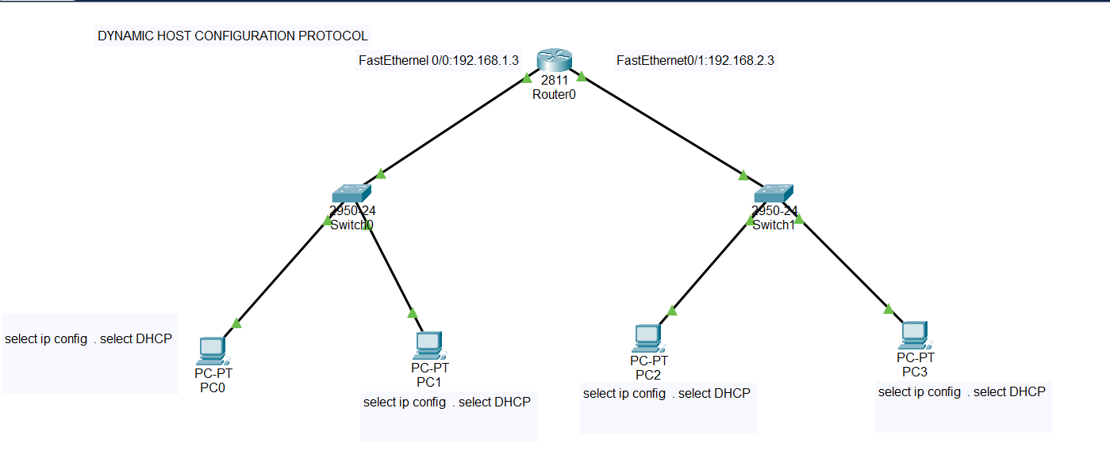

Configure Router1:-FastEthernet0/0
- Click on Router 1 go to command line interface(CLI)
- Router(config)#interface FastEthernet0/0
- Router(config)#ip dhcp pool p1
- Router(config)#network 192.168.1.0 255.255.255.0
- Router(config)#default-router 192.168.1.3
- Router(config)#exit

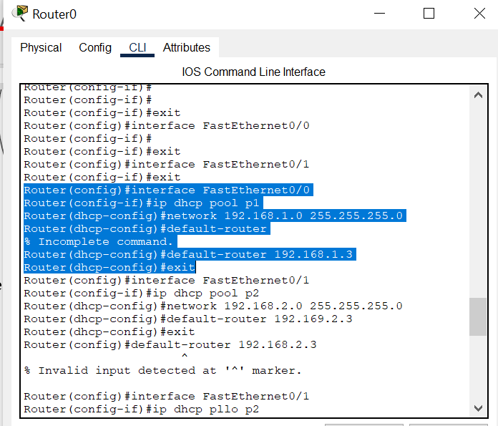

Configure Router1:-FastEthernet0/1
- Router(config)#interface FastEthernet0/1
- Router(config)#ip dhcp pool p2
- Router(config)#network 192.168.2.0 255.255.255.0
- Router(config)#default-router 192.168.2.3
- Router(config)#exit
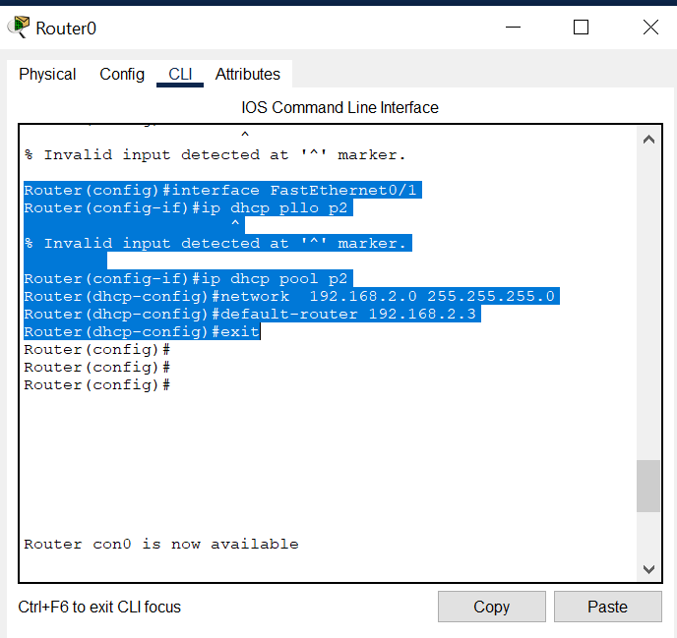

Configure PC0:-
- Click on PCO select desktop---> ipconfig
- IPconfiguration ----- > select DHCP
- Automatically IPv4 address, Subnet address, Default gateway will be configured and u can see message as DHCP request successful.

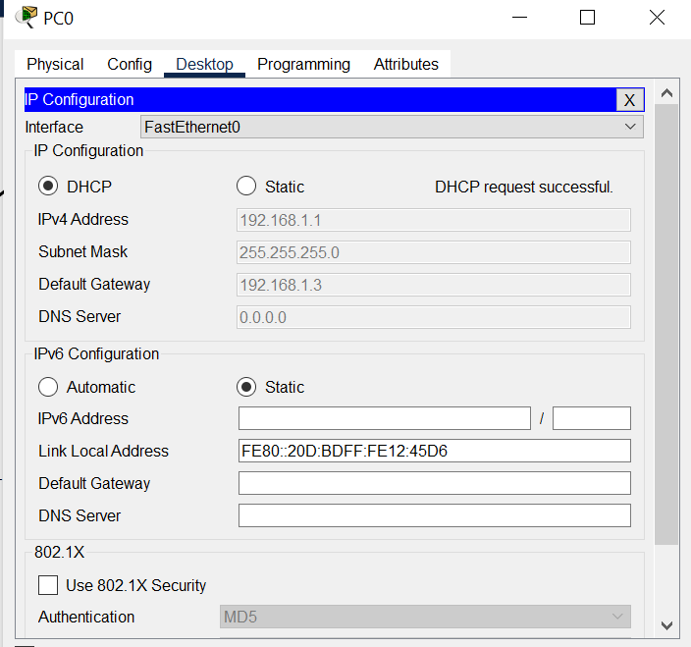

Configure PC1:-
- Click on PCO select desktop---> ipconfig
- IPconfiguration ----- > select DHCP
- Automatically IPv4 address, Subnet address, Default gateway will be configured and u can see message as DHCP request successful.

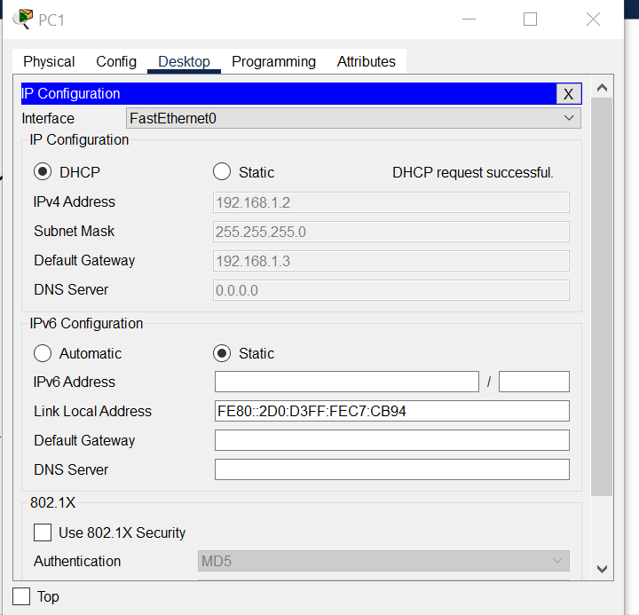

Configure PC2:-
- Click on PC2 select desktop---> ipconfig
- IPconfiguration ----- > select DHCP
- Automatically IPv4 address, Subnet address, Default gateway will be configured and u can see message as DHCP request successful.

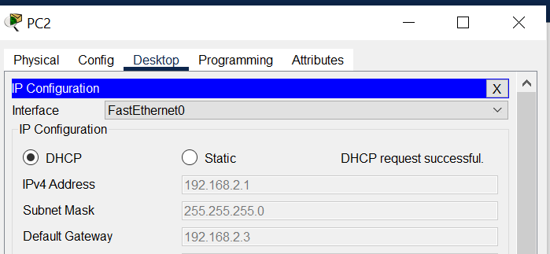
Configure PC3:-
- Click on PC3 select desktop---> ipconfig
- IPconfiguration ----- > select DHCP
- Automatically IPv4 address, Subnet address, Default gateway will be configured and u can see message as DHCP request successful.

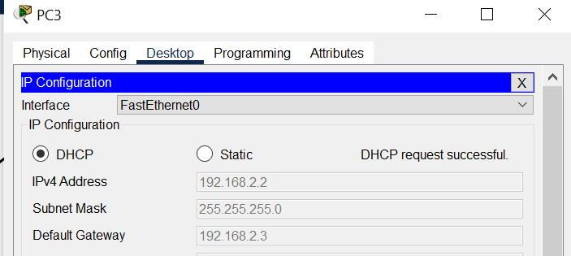

Output:-





